Capstone Project Assignment.

# Safe Community to Run a Convenience Store

Grant Gloster

12 May 2019

## Introduction:

### Background

Running a convenience store in the world today can be a very dangerous job. But not every community is as risky as the. By compiling crime statistics from law enforcement agency, one can gauge these answers. Combining this data with the Foursquare data we can work out saturation levels for the same types of stores in the area and adjust the location to ensure you have less competition.

By knowing this information perspective shop owners can see where is a good place to establish a business and at what time of the day are safer to run their business.

### Problem

Project aims to help investors to determine a safe and highly profitable community to invest into to build a convenience store using crime statistics and per capita income reports for communities of Chicago

### Interest

Business investors who want to commit money into a profitable investment by building stores.

## Data acquisition and Cleaning

### Data Sources

Crime statistics are a common data resource that is made available to the public by law enforcement departments. Chicago crime stats are available [here](https://data.cityofchicago.org/Public-Safety/Crimes-2001-to-present/ijzp-q8t2/data). This data is filtered on only 2018 incidents and the exported to a csv file that is uploaded to the “Data” folder in the project.

Chicago community boundary data is saved in a geojson file available [here](https://data.cityofchicago.org/api/geospatial/cauq-8yn6?method=export&format=GeoJSON). This is used to map out the neighborhoods when displaying data on the map. The file is uploaded to the “Data” folder in the project.

Community names and ID’s are compiled and displayed on a webpage [here](https://en.wikipedia.org/wiki/Community_areas_in_Chicago). This is processed and saved in an csv file. The file is uploaded to the “Data” folder in the project.

Chicago Per Capita Income is available as a csv export [here](https://data.cityofchicago.org/Health-Human-Services/Per-Capita-Income/r6ad-wvtk). The file is exported from the page then uploaded to the “Data” folder in the project.

### Data Cleaning

Data is imported from the uploaded files. This is then processed to get a usable format to start the assessment process.

The crime incidents data needs to be cleaned up to remove unnecessary columns that won’t be needed for data analysis. The features dropped are (**'Case Number', 'ID', 'FBI Code', 'X Coordinate', 'Y Coordinate', 'Year', 'Updated On', 'Location', 'Historical Wards 2003-2015', 'Zip Codes', 'Community Areas', 'Census Tracts', 'Wards', 'Boundaries - ZIP Codes', 'Police Districts', 'Police Beats'**).

Now the data is filtered on crime incidents where the “Location Description” is part of the following list (**'SMALL RETAIL STORE', 'DEPARTMENT STORE', 'CONVENIENCE STORE', 'GROCERY FOOD STORE'**). This will provide information on store related crimes in the different communities of Chicago.

Split the date into two separate features, date and time. Add an incident column at the end of the data that will be used to calculate community totals when processing the data.

The income data is also cleaned up by removing all the unneeded columns (**'PERCENT AGED UNDER 18 OR OVER 64','PERCENT AGED 25+ WITHOUT HIGH SCHOOL DIPLOMA','PERCENT OF HOUSING CROWDED','COMMUNITY AREA NAME','PERCENT HOUSEHOLDS BELOW POVERTY','PERCENT AGED 16+ UNEMPLOYED'**). This is then merge with the community’s data so that each community entry will have a per capita income and hard ship index.

## Exploratory Data Analysis

### Calculations

Taking the data available we group by Community Area and sum the Incidents on each row. This will give us a totals value for each community of the criminal incidents reported committed where location is a store. This will provide us information about the levels of crime in each community to help is make our first choice.

Taking the data we generate a bar graph which is ordered by total number of shop related crimes for the community’s for 2018.

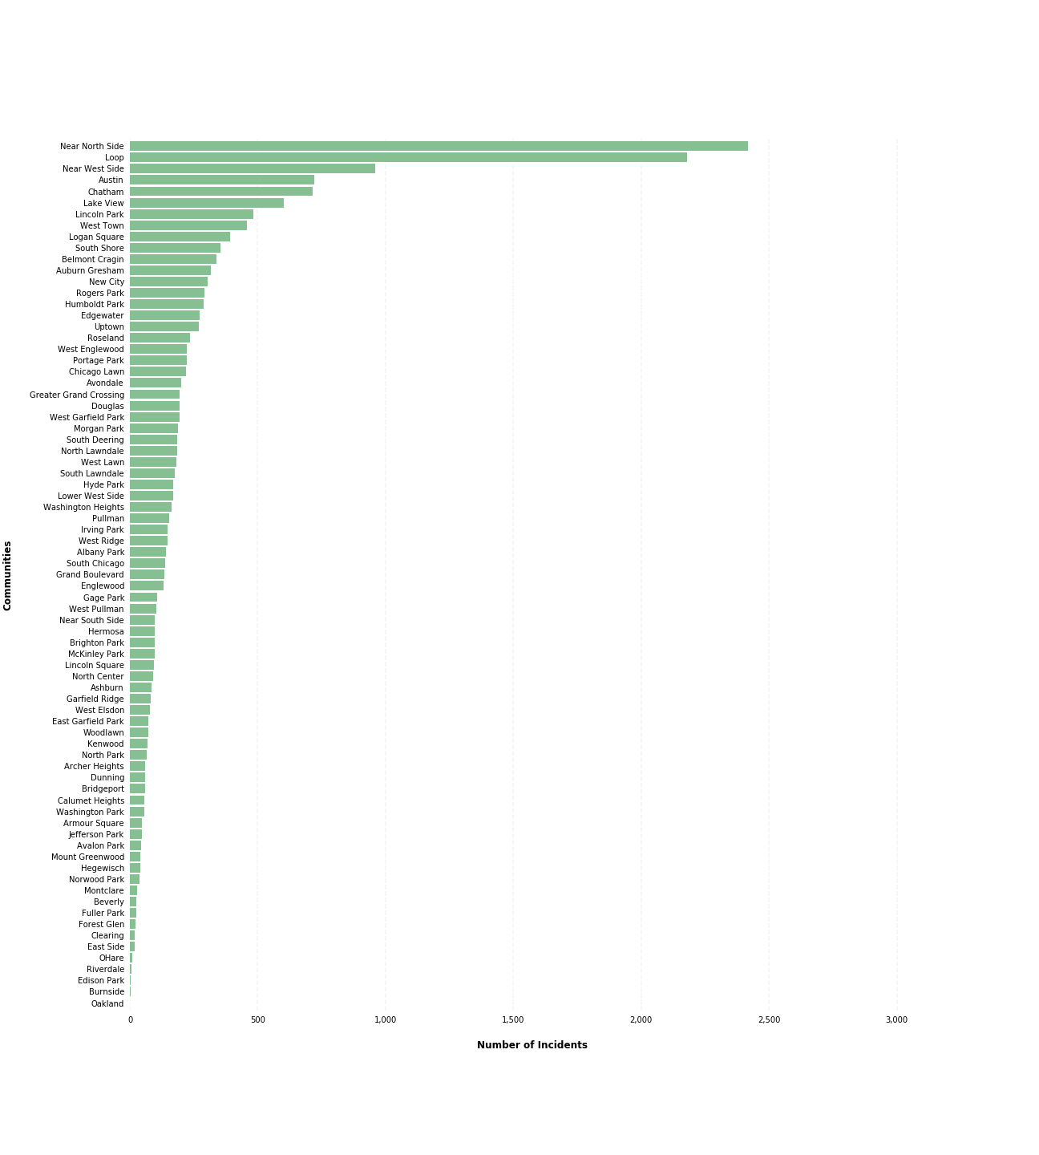

Using the data, we see there is a whole group of communities that have a very low annual incident counts. The bottom 20 communities are used for evaluation because the main purpose is to find the community that has the lowest incidents but also financially viable.

| **Community Area** | **Community Name** | **Incidents** | **PER CAPITA INCOME** | **HardshipIndex** | **Latitude** | **Longitude** |
| --- | --- | --- | --- | --- | --- | --- |
| 36 | Oakland | 0.0 | 19252 | 78.0 | 41.823653 | -87.60824 |
| 47 | Burnside | 3.0 | 12515 | 79.0 | 41.730035 | -87.59671 |
| 9 | Edison Park | 4.0 | 40959 | 8.0 | 42.005733 | -87.81400 |
| 54 | Riverdale | 6.0 | 8201 | 98.0 | 41.667835 | -87.60496 |
| 76 | OHare | 9.0 | 25828 | 24.0 | 41.973101 | -87.90676 |
| 64 | Clearing | 19.0 | 25113 | 29.0 | 41.780588 | -87.77338 |
| 52 | East Side | 19.0 | 17104 | 64.0 | 41.694618 | -87.53338 |
| 12 | Forest Glen | 21.0 | 44164 | 11.0 | 41.991752 | -87.75167 |
| 37 | Fuller Park | 24.0 | 10432 | 97.0 | 41.818089 | -87.63255 |
| 72 | Beverly | 26.0 | 39523 | 12.0 | 41.718153 | -87.67176 |
| 18 | Montclare | 27.0 | 22014 | 50.0 | 41.925309 | -87.80089 |
| 10 | Norwood Park | 37.0 | 32875 | 21.0 | 41.985590 | -87.80057 |
| 55 | Hegewisch | 40.0 | 22677 | 44.0 | 41.653646 | -87.54698 |
| 74 | Mount Greenwood | 41.0 | 34381 | 16.0 | 41.698089 | -87.70866 |
| 45 | Avalon Park | 45.0 | 24454 | 41.0 | 41.745035 | -87.58865 |
| 11 | Jefferson Park | 47.0 | 27751 | 25.0 | 41.969738 | -87.76311 |
| 34 | Armour Square | 48.0 | 16148 | 82.0 | 41.840033 | -87.63310 |
| 40 | Washington Park | 55.0 | 13785 | 88.0 | 41.792534 | -87.61810 |
| 48 | Calumet Heights | 57.0 | 28887 | 38.0 | 41.730035 | -87.57921 |
| 60 | Bridgeport | 59.0 | 22694 | 43.0 | 41.837938 | -87.65102 |

Using this list we plot out the community’s based on their incident counts. We can review the data to if the communities are in the same geographical locations or separated.

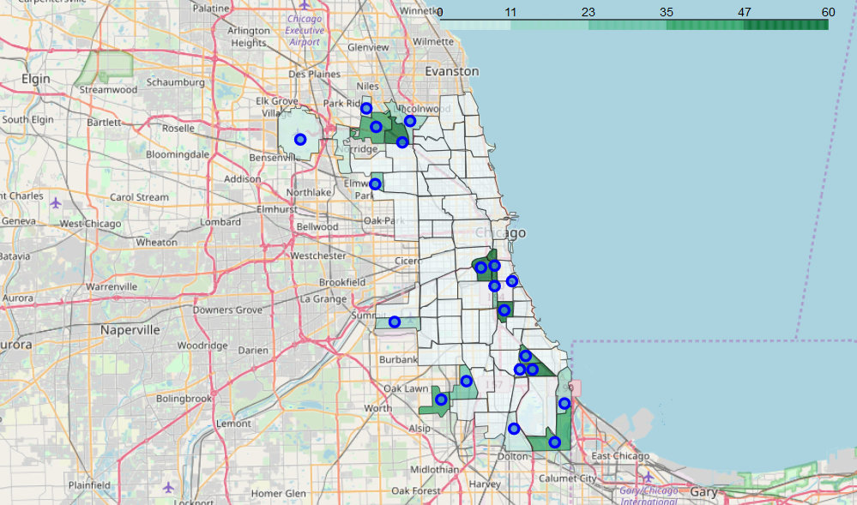

Every marker indicates a different community center point. As shown they are strewn across the city so our assessment is not localized to only one part of the city.

### Community Shops

Using FourSquare service provider, we retrieve all the shops that are listed for each community. This data is useful to provide a list of shops in the area to could be competitors for your business.

Using the data retrieved we calculate the frequency of each type of venue for the communities. We transpose the data and make each venue type as a different column value. Each row is a community and the value is the mean value of the venue frequency.

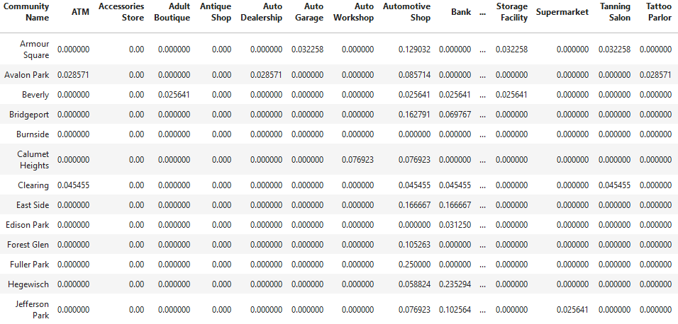

### Location, Location, Location

Because the data set has 91 columns and 20 rows it makes it difficult to assess the data visually. So, to make it more readable we need to calculate top 10 most common stores in the area. This will give us an indication if there are a lot of convenience stores and what other types of stores are available that might bolster our business.

The data is ordered by hardship index from lowest to highest which will help show more affluent areas. Taking this and comparing it to the incidents counts we analyze the data to make a decision on the community to pick.

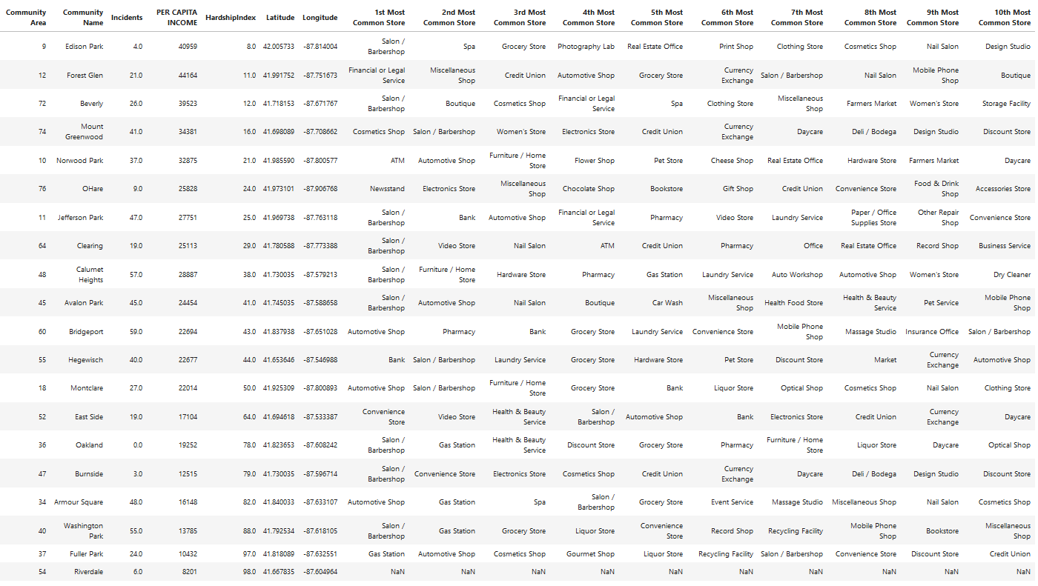

### Assumptions

Looking at the data it shows that Edison Park is at the top of the list. Low hardship index and incident value but the third most common store in the area is Grocery Store which means lots of possible competition. This also shows that there is a market for grocery stores in the area and the more unique the store the good possibility to be successful.

Forest Glen is a good option but it has a high incident rate for a community where the Grocery Store is the 5th most common store. So, lots of incidents for the few stores that are available. But it is the most viable because as you progress down the list the count of incidents goes down but the per capita income for the community goes down as well. This will affect the type of store you want to put up and the type of products you will sell to the public.

## Conclusion

Using this type of format, you can review different cities and communities for a low incident area to invest into a store. The biggest problem will be cleaning up the data at the start and putting it in a usable format to be assessed. The data is mostly available for big cities but some areas do not supply all related data needed.

<https://gist.github.com/3b65fa4698c75a3c3a11838385ef3fe4>